EARTH SCIENCE SPECIAL FEATURE
The Shaking Earth: Causes of Earthquakes
Earth feels solid under our feet. However, our planet's crust (the hard, rocky outer layer of Earth) is broken into huge pieces. These pieces are called tectonic plates (giant puzzle pieces that make up Earth's outer shell). Tectonic plates float very slowly on a softer layer of hot, melted rock deep inside the Earth. They move only a few centimetres each year.
As these plates float, they interact in three main ways. First, some plates pull apart from each other. Second, other plates bump into each other. This bumping can push the land up to form giant mountains. Third, some plates slide sideways past one another. The areas where these plates meet are called boundary zones.
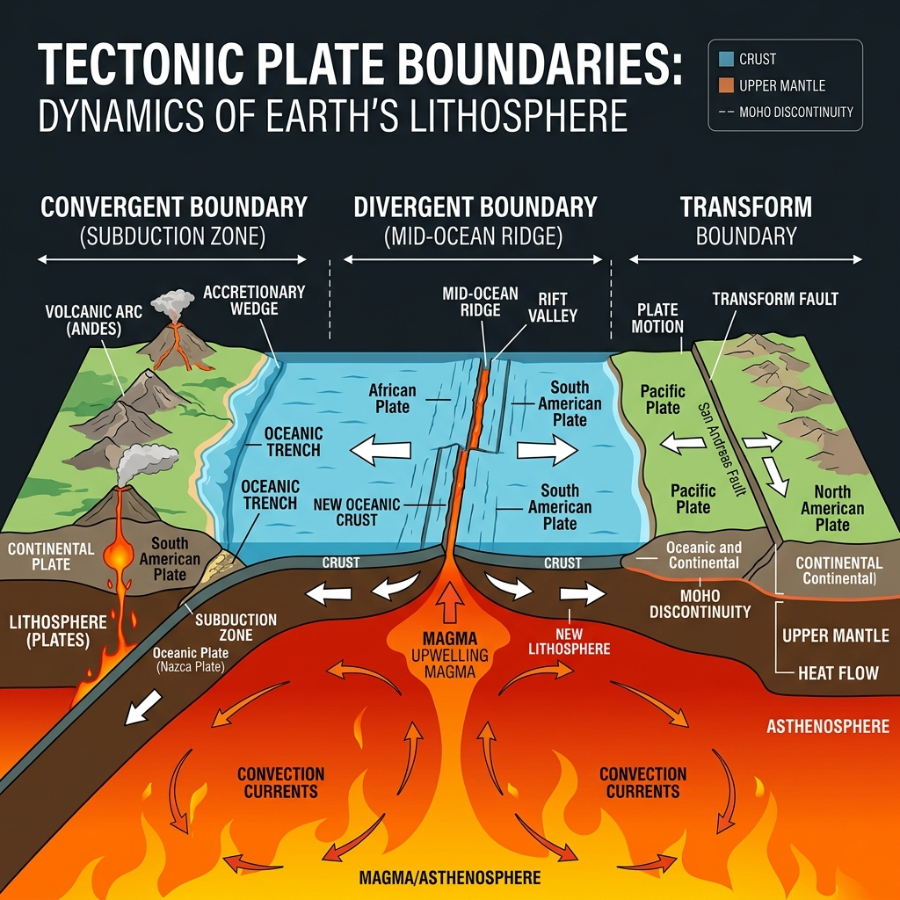
Tectonic Dynamics: Tectonic plates floating on a softer, molten rock layer beneath Earth's outer crust. Arrows indicate the different ways plates interact: pulling apart, pushing together, or sliding sideways.
The edges of tectonic plates are rough and jagged. As the plates try to move, their rough edges can get stuck together. They stick because of friction, which is a force that resists movement. Even though the edges are stuck, the rest of the plates do not stop moving. They continue to push and pull. This build-up of force creates tension (growing pressure that is stored in the rocks along the boundary).
"Even though the edges are stuck, the rest of the plates do not stop moving... This build-up of force creates tension."
— TECTONIC MECHANICS

Over time, this pressure becomes too great. The rocks suddenly break or slip. This sudden movement usually happens along a fault (a crack in the Earth's crust where rocks can move). When the rocks suddenly slip, they release a massive amount of stored energy.
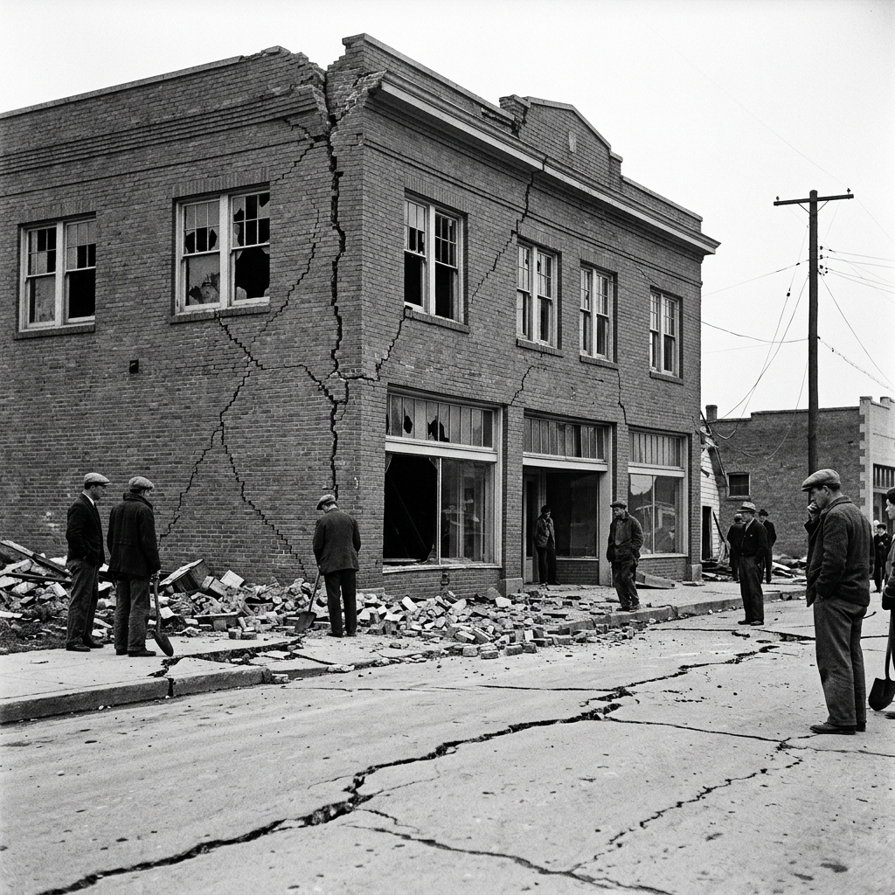
Energy Released: The aftermath of a historical earthquake, demonstrating how massive amounts of stored tension can fracture solid brickwork and split paved roads along active fault lines.
This energy travels outward from the break in all directions. It moves as seismic waves (powerful ripples of energy that travel through the ground). These waves make the ground shake. This shaking is what we feel as an earthquake. The point deep underground where the rocks first broke is called the focus. Directly above this point, on the surface of the Earth, is the epicentre (the point on the surface directly above where the earthquake started). The shaking is always strongest near the epicentre. Smaller shakes called aftershocks (smaller earthquakes that happen after the main shaking) can occur for days or weeks.
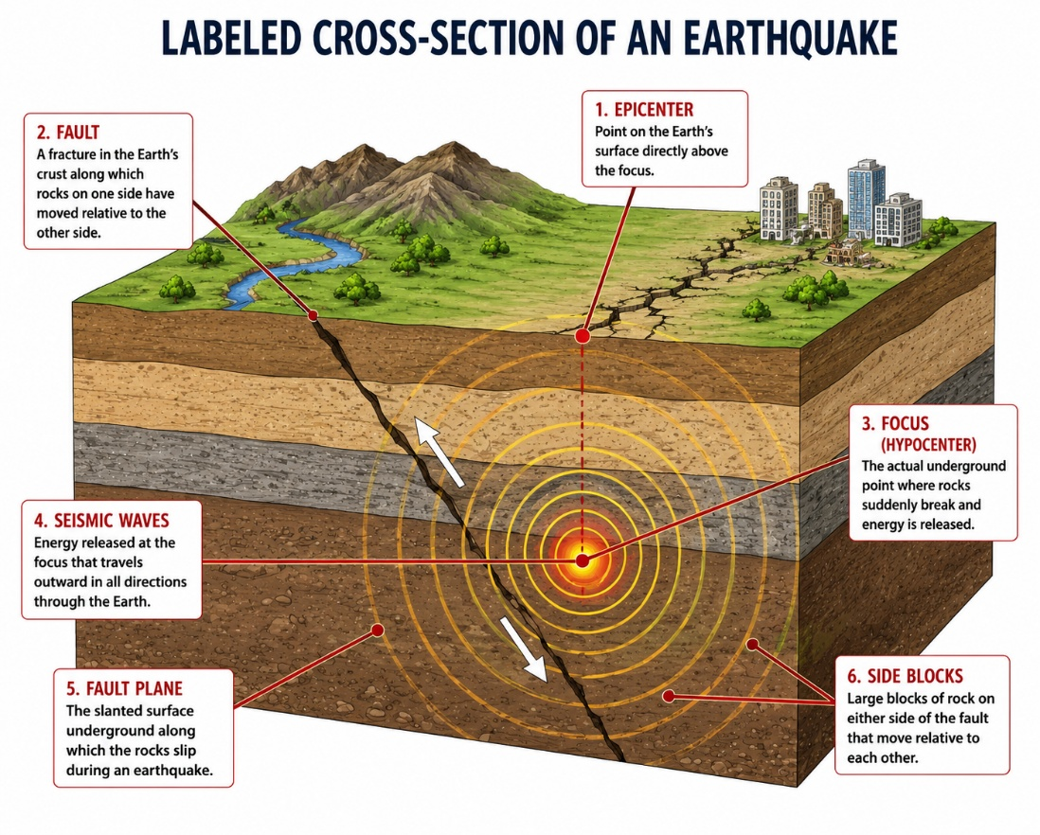User Image Insertion Area: Labeled diagram showing focus, epicentre, fault line, and seismic waves ]
Figure 1 - Earthquake Cross-Section: A cross-sectional view of an active earthquake zone, highlighting the focal point underground, the surface epicentre, and the propagating circular energy waves.
Scientists measure earthquakes using a seismograph (a special machine that measures the strength of ground movements). By studying earthquakes, we learn how tectonic plates move and how to build safer buildings to protect people.
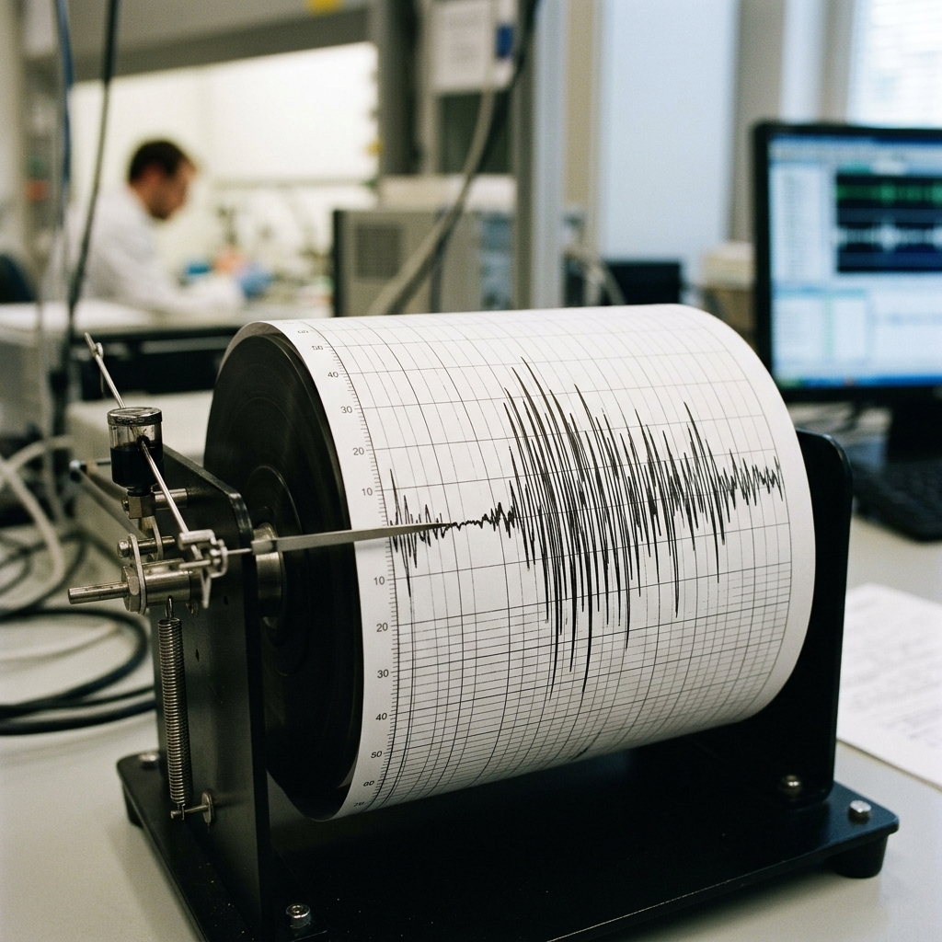
Measuring Shaking: A close-up of a seismograph machine translating raw seismic energy waves into measurable line ripples on paper.
KEY TERMINOLOGY
Epicentre: The point on the surface directly above the underground start of the earthquake.
Fault Line: The crack in the Earth's crust along which rocks can move.
Focus: The deep underground point where rocks first fracture and slip.
Seismic Waves: Circular energy ripples spreading through the ground.
Seismograph: A special machine that measures the strength of ground movements.
Tectonic: Relating to the structure of the Earth's crust and the large-scale movements of the plates that form it.
Tectonic Plate: A giant puzzle piece of the Earth's hard, rocky outer crust.
Tension: Growing pressure that is stored in rocks when tectonic plates get stuck.

Plate Boundary Types (Field Comparison Table)

Boundary Type | Direction of Movement | Geological Features Produced
Convergent Boundary | Plates push into each other | Fold mountains, deep ocean trenches, and strong earthquakes
Divergent Boundary | Plates pull apart from each other | Rift valleys, volcanic activity, and mild earthquakes
Transform Boundary | Plates slide sideways past each other | Active fault lines and shallow, destructive earthquakes

